Experiment 6: Depth First Search (DFS)
Aim
To implement Depth First Search (DFS) using Python.
Objective
To traverse all nodes of a graph using DFS.
Algorithm
- Create a graph.
- Start from the source node.
- Visit the node.
- Recursively visit all unvisited neighbours.
- Repeat until all nodes are visited.
Flowchart
Start
|
Create Graph
|
Visit Node
|
Unvisited Neighbour?
/ \
Yes No
| |
Visit Backtrack
\ /
Repeat
|
Stop
Code
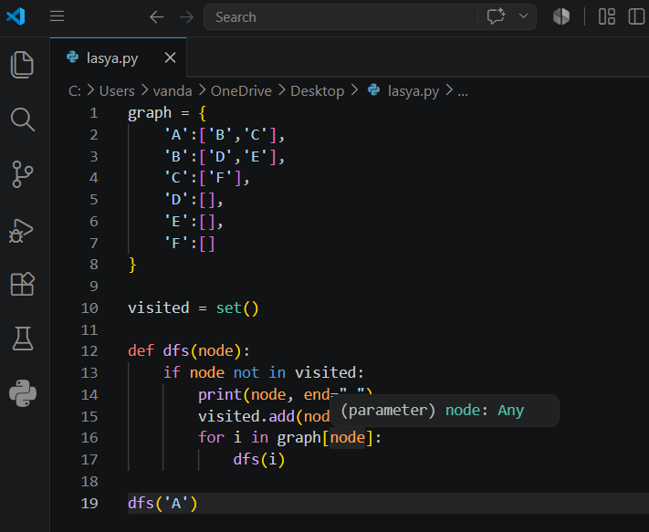
Output:
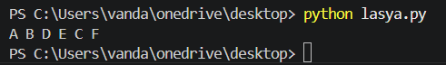
Result
The graph was traversed successfully using DFS.
Conclusion
DFS visits nodes by exploring each branch completely before backtracking.

